**Sattelite area check for EH&S**

1. Take the [Lab Safety and Hazardous Waste Generator Training (Web)](https://colorado.bioraft.com/node/1904108) training and get your certification.
2. Log into BioRAFT and click “View Lab Profile

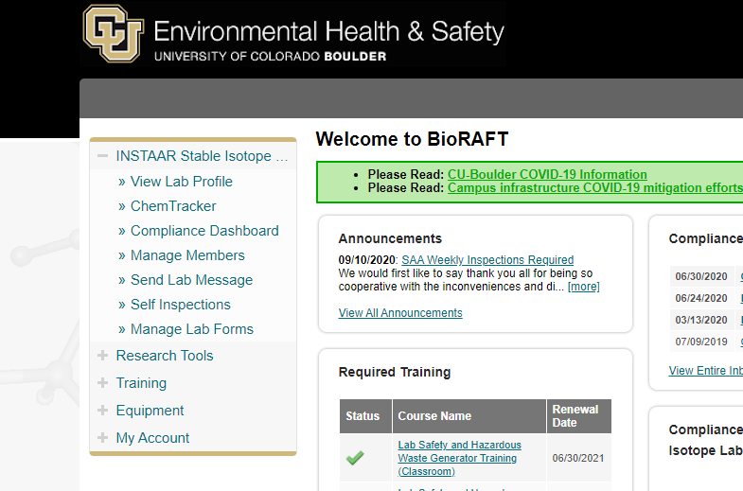

1. Click View 🡪 Equipment

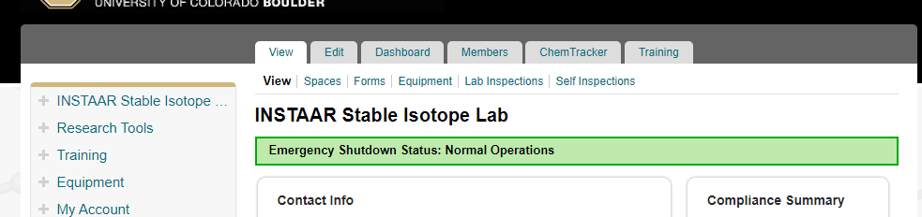

1. Click “Bulk Add Audits”

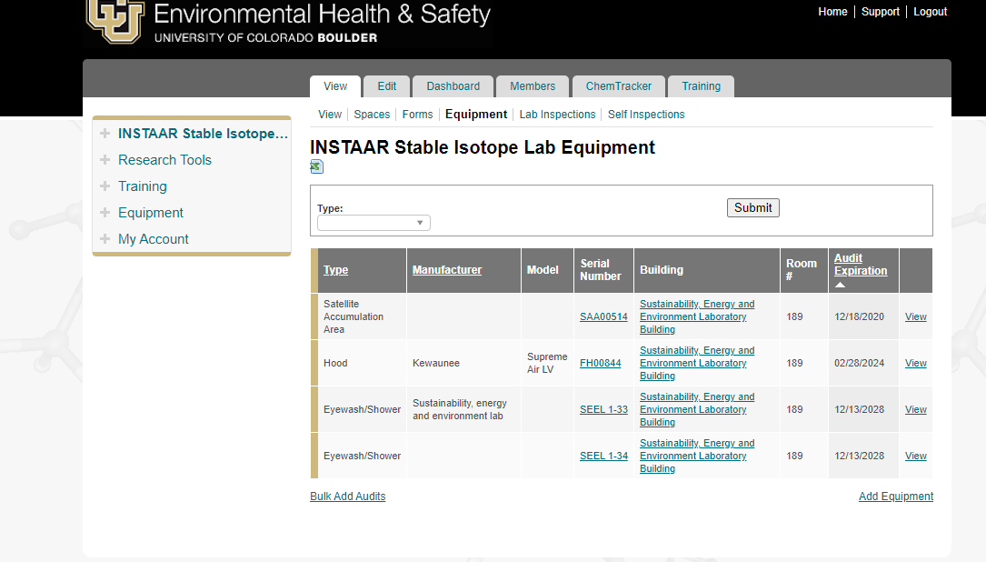

1. Select “Stateline Accumulation Area”, then “SAA Weekly Inspection” and click the little checkbox by the correct building and room number. Then, click next.

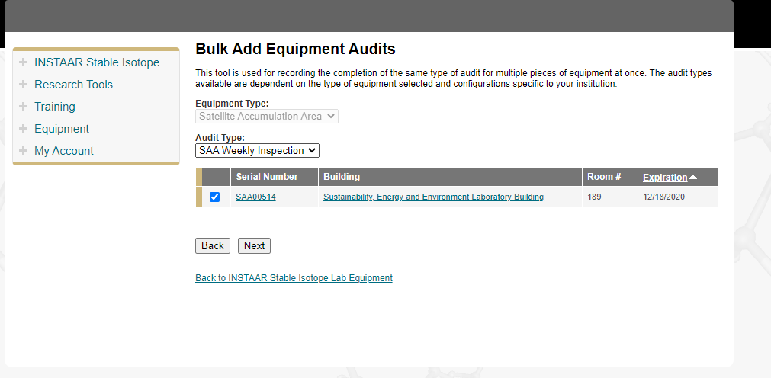

1. Make a reference number (usually I just use the date--for this example the reference number would be 12172020). At this point I go and visit the lab to make sure the SAA fulfills all of the requirements listed below, as well as the requirements that you learned from the lab safety and hazardous waste generator training. Select whether the room passes or fails, and write notes why, if you would like.

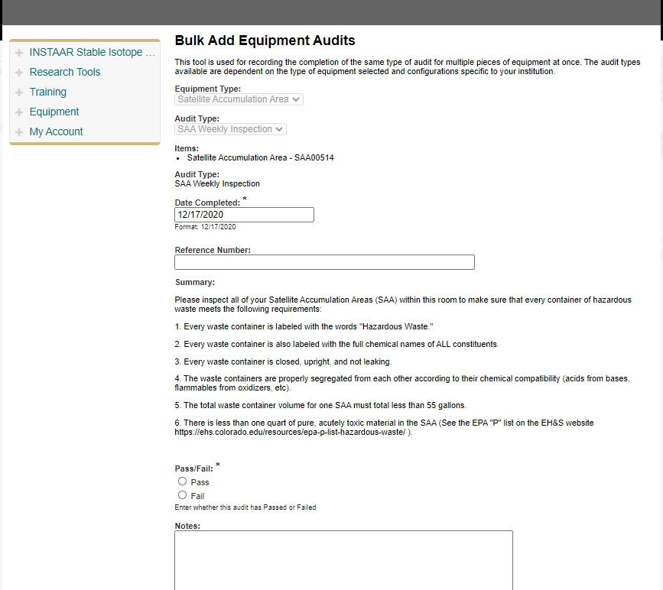

1. Click “Submit” at the bottom of the page to submit the report. This will take you to a page that lets you know your report has been submitted. You’re done for the week!
2. Do it all again a week later ☺